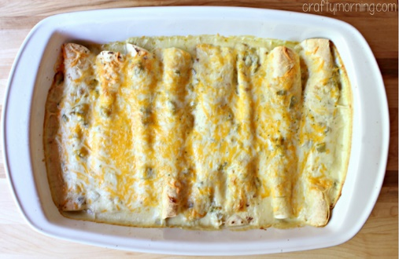
White Chicken Enchiladas
Prep Time 5 min Cook Time 35 min
4 Servings
Ingredients
2 cups shredded Monterey Jack cheddar cheese
8 small flour tortillas soft shell
3 tbsp butter
1 cup sour cream
4 oz can of diced green chiles
2 cups shredded chicken about 1 big chicken breast
3 tbsp flour
2 cups of chicken broth
Directions
- Heat oil in a skillet and cook chicken until no longer pink in the middle, about 5 minutes each side.
- Let the chicken rest. Shred chicken.
- Mix chicken with shredded cheese.
- In a saucepan, melt the butter and add in the flour. Mix and cook for about one minute.
- Add in the chicken broth, whisking until it’s a smooth consistency. Whisk over medium heat until it is thick and creamy (usually takes about 5-8 minutes).
- Mix in the sour cream and the can of chiles to the pan.
- Preheat oven 425 degrees.
- Lay eight tortillas out and fill each one with the chicken mixture making sure they are all even. Roll them up tightly and put them in a greased 9×13 baking dish.
- Pour the creamy sauce over the rolled-up tortillas evenly.
- Add 1 cup of the cheese over the top.
- Bake for 15 to 19 minutes in a convection oven (20 to 25 minutes in oven) or until the cheese is golden brown. Add salsa or cilantro and you’re ready to eat!

